Dell Migration  
Tool (DMT)

DMT Client Installation Services Work Instructions | Version 2.0.0 | Document Revision 2.0

Contents

Definition of Terms 3

Dell DMT Overview 3

Cautions and Requirements 3

Prerequisites 3

Local Administrative Rights 4

Enough Space on New PC to Backup Data 4

Power 4

Functional Hardware 4

Docking Stations 4

During Data Migration 4

Execution 4

Migration Steps. 5

Profile Pairing 5

Restore Disk Space Check 5

Domain Checks 5

Executing the Network PC to PC Migration 7

Executing the Any Drive Migration 8

Executing the Cloud Sync Migration 9

Verify Cloud Sync on Old PC 11

MD Update Results 12

Post Migration steps 12

Logon to End User Profile 12

Temporary Account Cleanup 12

Additional Sync Screens 13

Known Issues and Resolution 14

General DMT Troubleshooting 14

Network PC2PC 15

AnyDrive 15

Support 15

Technical Contact Information 15

# Definition of Terms

The following is a glossary of terms that may be used throughout this instruction document:

**DMT** – Dell Migration Tool

**Target PC/New PC** – Is the desktop, laptop or workstation that represents the “new” or “replacement” machine that is being deployed.

**Source PC/Old PC** - Desktop, laptop or workstation that represents the existing machine to be migrated from.

**AnyDrive** – Scenario to select “Any” drive that allows for browsing to a location for the backup/restore of the data, such as USB drive, mapped drive or network share.

**Network PC2PC** – Scenario that allows connection to be made from Source PC to Target PC over the network. Both PC’s must be on the network at same time to allow the connection to be made. Target PC name or IP Address is required.

**Cloud Sync** – Scenario that allows moving user profile and data into the One Drive sync folder.

**DMTBackup.exe** – Executable to run on the Source PC

**DMTRestore.exe** – Executable to run on the Target PC

# Dell DMT Overview

The Dell Migration Tool (DMT) was developed to simplify the migration of data from an old operating system to a new operating system. This document addresses using DMT with Client Installation Services when transferring data from a Source PC to a Target PC.

* Reduced end-user down time
* Maximized technician multitasking
* Automated user data and settings migration

# Cautions and Requirements

## Prerequisites

These components may be used during the process, depending on the DMT scenario selected.

* External USB drive (if AnyDrive). **USB Drives must be formatted as NTFS**.
* Network share/ Mapped drive (if AnyDrive)
* If using Cloud Sync, the end user must already have One Drive license with adequate storage to sync the amount of local data.
* Source PC (Old PC)
* Target PC (New PC)
* DMTBackup.exe
* DMTRestore.exe
* Internet access is required for reporting and *service desk remote access*

Local Administrative Rights

An account with local administrator rights is required to run the tool, it can be a local or domain account (with cached credentials, depending on the selected scenario).

## Enough Space on New PC to Backup Data

For Network PC to PC, the data will be backed up directly to the Target PC, on the largest available physical drive. It should have enough free space to temporarily hold all the data to be migrated from the source computer and to restore that data  
  
**NOTE**: Before you start any data migration, you should check the Target PC’s hard drive to determine if there is enough space to house both the temporary backup file as well as the restored data. This is required because the temporary backup file does not free up space until after the restore completes at the end of a successful migration. This step is most important for computers with only one physical drive. If only one drive exists on the New PC and it is noticeably smaller than the amount of storage used on the Old PC, the backup itself will likely fail. You should contact the support desk if this outcome is suspected.

If there are two physical drives, DMT will use the larger drive for this temporary storage. However, it is possible the primary OS drive is much smaller than the secondary drive. You may be prompted during the migration to contact help desk or branch manager if a disk drive space is detected. These details are covered in the "**Restore Disk Space Check**” section.

## Power

Laptops ***must*** be connected to AC power. Deployments will fail on battery power alone, even with a fully charged battery. Ensure an appropriate power supply is connected to a stable power source.

## Functional Hardware

Machines **must** be fully functional. Machines that have hardware problems or that hang up/freeze, may also hang up and fail during the migration process.

## Docking Stations

Neither PC should be in a docking station for this process. It can be returned to the docking station when the process is complete for normal operation.

## During Data Migration

Neither PC should be used during the data migration process. If files or applications are open on either PC, it could prevent the migration of data or cause errors to occur.

# Execution

There are three CIS options available for executing DMT for data migration; Network PC to PC, Any Drive, and Cloud Sync. Network PC to PC should be the primary selection, as it is the fastest method to transfer the data while maintaining a connection to the internet on both PC’s. Cloud Sync can be used is user is already licensed to use One Drive.

Should any connection problems occur while migrating data directly from the Old PC to the New PC (using PC to PC), Any Drive can be used to back up the data to available media, and then restored as a subsequent task once the backup completes.

# Migration Steps.

## Profile Pairing

Prior to the data restore on the New PC there might be a “Pair Users” selection screen. This will only be seen if existing accounts are detected on the New PC and both Old and New PC are in Workgroups, not joined to a Domain. If displayed, this will allow you to restore the legacy profile to an existing profile on the New PC (most commonly a Microsoft Account). If no account is selected to be paired, the legacy account(s) will be restored to the same account name it had on the Old PC, which could be different than already created account(s) on New PC. If there are no local profiles created prior to DMT running (exceptions are DellTech and Administrators), DMT will continue as normal and this prompt will not be seen.

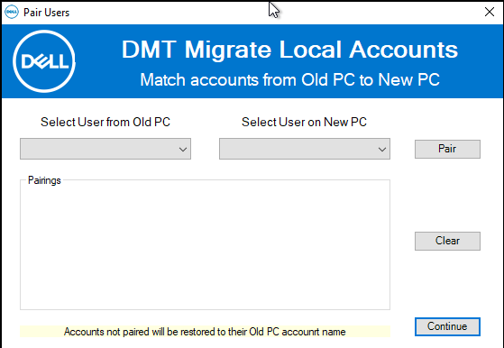

Restore Disk Space Check

After a successful backup completes, DMT will compare the size of data to restore to the storage on available drive(s) prior to the restore beginning. If the backup store is too big to fit on the C: drive and a second hard drive with available space is detected in the system, DMT will restore the profiles to that larger drive, unless those profiles were paired. The following are possible messages that could be displayed if not enough storage is detected prior to the restore.

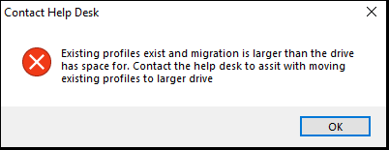 If you see this message call the DMT support desk for a resolution. This is likely due to existing profiles that were paired and there is not enough storage to restore on the drive where those profile(s) already exist.

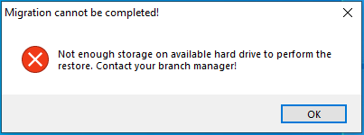

If you see this message, contact your branch manager. This indicates there is not enough disk space at all to perform the restore.

## Domain Checks

DMT will show a prompt if the old system was on a domain and give you the opportunity to add the New PC to the domain. Selecting “Yes” will close the DMT and allow you to join the domain. Once joined you must then reboot the PC, rerun DMTRestore.exe, select your migration method, and it will continue with the restore process. Alternatively, selecting “No” will continue with the data restore, however the profile will not be accessible until this system is joined to the domain.   
  
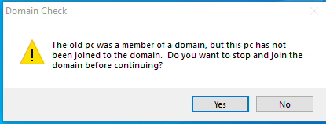

# Executing the Network PC to PC Migration

|  |  |
| --- | --- |
| **Steps on New PC** | **Steps on Old PC** |
| 1. **DMTRestore.exe and select “Network PC to PC” click Next** | 1. **DMTBackup.exe, select “Network PC to PC and click Next** |
| New PC will wait for Backup to complete | 1. **Enter New PC Name or IP and click Next** |
| New PC will restore data | 1. **Verify New PC Name and click Next** |
| 1. **Restore completes, click OK** | **Data will backup to New PC** |
|  | 1. **Backup completed, click OK** |

# Executing the Any Drive Migration

|  |  |
| --- | --- |
| **Steps on Old PC** | **Steps on New PC** |
| 1. **DMTBackup.exe, select “Any Drive” click Next** | 1. **DMTRestore.exe, Select “Any Drive” then click Next** |
| 1. **Select the location to store the backup (i.e. USB drive, network location, etc…) Click Select Folder to continue.** | 1. **Select the location where the backup was stored (i.e. USB drive, network location, etc…) Click Select Folder to continue** |
| Data will backup to selected location | Data will restore from the selected location |
| 1. **Backup completes, click OK** | 1. **Restore completes, click OK** |

# Executing the Cloud Sync Migration

Prior to executing DMT for migrations that have been identified as OneDrive users, verification of the amount of storage available based on the customers subscription level should be done. This is to ensure that there will be adequate storage with their subscription to Sync the data that DMT will move to the local Sync folder. For example, if user is only using the free basic Personal One Drive subscription, they would be limited to only 5GB of data, which in most cases would not be enough storage. Corporate customers using OneDrive for Business will likely have adequate storage for their users and could be identified by an IT point of contact.

Once the storage amount is identified, it should be compared to the estimated data size from the PreDeploy script. If the PreDeploy script has not been run, it can be run to also generate that estimated data size.

If it is determined there is not sufficient amount of cloud storage, the customer can be informed that can upgrade their subscription with Microsoft or Dell can prefer a traditional data migration from old pc to new pc when the new pc arrives and tech is on site to establish a remote connection for Dell to execute that migration.

The following steps can be used to check the amount of storage available for the customers OneDrive subscription:

**Click the OneDrive cloud icon in the task tray, then Help & Settings then Settings. On the Account tab of the Settings, you should see the amount of cloud storage available based on the customers subscription. Ensure this is adequate for the estimate mount of data that will be moved to the Sync folder.** 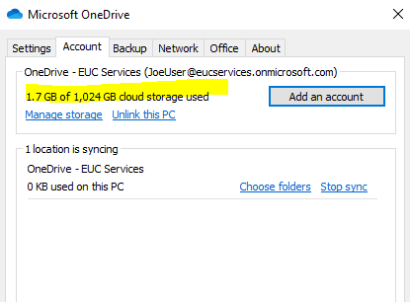

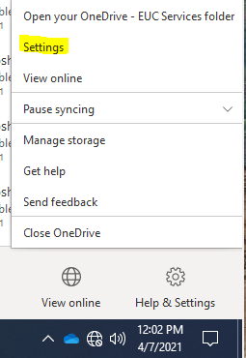

|  |  |
| --- | --- |
| **Steps on Old PC completed prior to deployment** | **Steps on New PC at time of deployment**  **See** **Verify Cloud Sync on Old PC** |
| 1. DMTBackup.exe, select “Cloud Sync” click Next | 1. DMTRestore.exe, select “Cloud Sync”, click Next |
| 1. Select Profiles folders, custom folders required and Sync Folder or accept default settings. Click Continue | 2. Select Profiles folders, custom folders required and Sync Folder or accept default settings. Click Continue |
| 1. Folders will be moved, and Settings (see restore image) will be backed up if selected. | 3. Folders will be moved (see backup image), and Settings will be Restore if selected. |
| 1. Backup to Sync completes. Click Ok to exit. Verify folders are in Sync. | 4. Restore to Sync completes. Click Ok to exit. Verify folders are in Sync. |

# Verify Cloud Sync on Old PC

|  |  |
| --- | --- |
| **Steps on Old PC to Verify Sync has Completed** | **Check for Files that did not Sync** |
| 1. Run DellSyncCheck.exe. Will check for Sync Accounts from DMT logs: | If some files are blocked from synching, customers can be notified to act. Most files will sync; however, some could be blocked by policy, characters or other restrictions. This link further explains why some files may not Sync.  <https://support.microsoft.com/en-us/office/invalid-file-names-and-file-types-in-onedrive-and-sharepoint-64883a5d-228e-48f5-b3d2-eb39e07630fa#invalidblockedfiletypes> |
| 2. If DMT logs are found, the account moved to Sync will be used. If DMT logs cannot be found and multiple accounts detected, will be prompted to select account: | If files are blocked from Syncing, a red x will be displayed on the One Drive Sync icon in the task tray.    Clicking on this icon will open the OneDrive menu options and a message will be displayed requiring your attention. The number of items unable to sync will also be shown. |
| If Sync is detected to still be in progress, this will be shown. Once sync is completed, user will be notified as completed. | Clicking where it says “Tap or click for more info” will then display the files that are unable to be synced. Resolutions are to rename or remove from OneDrive. |
| When Sync Completion is Detected:    If other screens are shown for errors or not shown above, refer to this section: Additional Sync Screens |

# MD Update Results

When DMT completes the restore on the New PC, a script is called to update the deployment management system with the results of the data migration. Depending on the results of that script, the **MD Update** results (shown in the summary screen) will be one of the following:

* **“File not found!”:** This indicates the script to be called was not found in any known locations. This is generally a configuration issue where the script was not included in the DMT package.
* **“Success”:**  This indicates the script was called and executed successfully.
* **“Failed**”: This indicates the script was called but there was an error executing the script. The logs will need to be checked for further analysis.
* **"Internet access required, rerun using 'MDUpdate' from Desktop**": This indicates the script was called but could not access the internet to report the data and a shortcut is created on the Desktop called “**MDUpdate**”. This might be common in a peer to peer migration where the two PC’s are connected together and off the network. In this event, the New PC should be connected to the network and the shortcut from the desktop can be ran. Upon success, the data will be reported, and the shortcut will be removed. If the shortcut is not removed from the desktop after executing, the logs will need to be checked for further analysis. If the MDUpdate cannot be run, the data migration information should be manually collected via the defined process and spreadsheet to upload later.

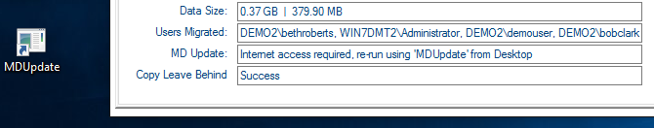

# Post Migration steps

## Logon to End User Profile

Once the migration is completed, if you are not currently logged in with the customers User account, you should log out of the account you used to perform the migration and have the customer login to their profile or each profile that was migrated. Once logged in, have the customer validate data to ensure everything came over, and that their outlook was setup if applicable. This should happen for every migration and is required for the customer to sign off on the job.

## Temporary Account Cleanup

Only if a temporary account was used for the migration, the migration is completed and you have logged into the End Users profile, any temp accounts created for migration (MigrateAcct, or Delltech) should automatically have been removed from the system. In the event they are not you will need to remove the accounts from the customers computer. If you did not create any temp accounts, there will be nothing to do for account cleanup.

# Additional Sync Screens

If Sync is Paused during sync check:

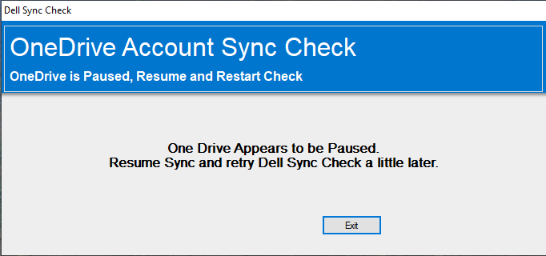

If no Sync logs are found during sync check:

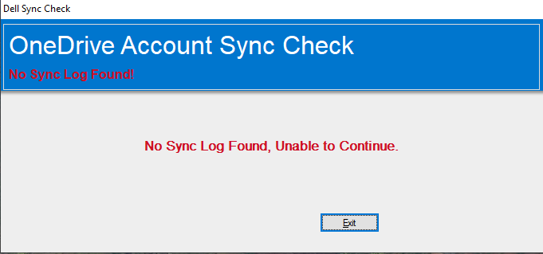

If an error occurs or undetermined state found during sync check:

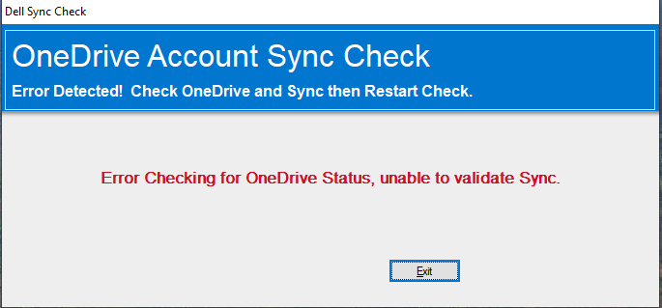

# Known Issues and Resolution

The following section identifies known deployment issues, causes and resolution.

**Place holder for known issue, cause & resolution documentation**

You may find more up to date and additional information on troubleshooting and other info on the Teams Site Wiki:

[**DMT WIKI**](https://teams.microsoft.com/l/channel/19%3A7b4dd79c8b4740cab699ee64e3778dfa%40thread.skype/tab%3A%3Adb35efe9-bfca-493b-aa7c-2da31be4f360?groupId=20d93e3d-8e67-4cc6-9740-355a4c89a794&tenantId=945c199a-83a2-4e80-9f8c-5a91be5752dd)

## General DMT Troubleshooting

* + **Cause:** Need to check Logs?
  + **Resolution:** Log location on both Old and New PC: *C:\Windows\Dell\Logs*
  + **Cause**: DMT may not be running as an Administrator
  + **Resolution**: Ensure DMT is running as admin account. This can done by right clicking on the DMT executable and selecting “Run as administrator”. If you are prompted for credentials you are not logged in with an Admin account and will not be able to perform migration until Admin credentials are provided.
  + **Cause**: Source PC starts the Data backup process, and immediately errors out. Log files references Temporary profiles being active.
  + **Resolution:** Open Registry and navigate to HKEY_LOCAL_MACHINE>SOFTWARE>MICROSOFT>WINDOWS NT>CURRENT VERSION>PROFILE LIST. – Under this folder structure you will see a series of SIDs, any of those SIDs ending in .BAK will call the migration to fail, and need to be cleared out.(Highlight and delete)
  + **Cause: WMI error**
  + **Resolution**: Refresh the WMI repository. Stop the WMI service, delete the repository located in C:\windows\System32\wbem\Repository and restart the WMI Services.

## Network PC2PC

* **Cause**: DMT may not have been started on both the Source and the Target PC
* **Resolution**: Ensure DMT is running on both Old and New PC’s
* **Cause**: Third party firewall could be blocking connection attempts
* **Resolution**: If possible, disable or allow openings required for connection to be made during the data transfer. Firewall should be reset or reenabled manually on completion.
* **Cause**:  DMTRestore.exe may not have been started on New PC with “Network PC to PC” selected.
* **Resolution**: Run the DMTRestore.exe on the New PC and select “Network PC to PC”, click Next to continue. Then on Old PC, select OK on error message and click Next to try again. Ensure both PC’s are connected to the network.
* **Cause**: DMT is unable to connect to the New PC
* **Resolution**:
* Verify share was created.
* Verify permissions to share
* Verify both machines are on the same network.
* Verify that the computer name was entered correctly

## AnyDrive

* + **Cause**: USB Drive not seen or available for use in DMT
* **Resolution**: USB drives must be formatted NTFS.
* **Resolution**: Verify policies aren’t in place that prevent USB drives from launching applications.
  1. Try copying the DMT files locally and run from there.
* Data missing (Unable to see data on New PC)
  + **Cause:** Unable to locate the user’s data post migration.
  + **Resolution:**  Reboot the new computer and login to the PC with the same Windows Account that was used on the OLD PC. <NOTE: if logging in for the first time, you will be asked to change the password. Leave the OLD PASSWORD field blank.>

# Support

## Technical Contact Information

Contact us by email.

* Contact Level 3 Support or send email to DMT L3 Support (dmt.l3.support@dell.com)