New System

1. Disconnect the customer’s old computer and move aside to a safe location.
2. Unbox the new computer and set it up in the final location, per the customer’s specifications.
3. Install software per the dispatch/manifest, if required.
4. Set up peripherals per the customer’s specification or the manifest, if required.
5. Connect to internet and power.
6. Refer to the Establishing a remote session with the Service desk.

Old System

1. Reconnect old system in a safe location, free of tripping hazards.
   1. If customer only has one monitor you will need to swap between the old and new PC
2. Connect to the internet and power.
3. Refer to the Establishing a remote session with the Service desk.

Establishing a remote session with the Service desk

1. Ensure you have completed all steps for the new and old systems prior moving forward and **both old and new systems are connected to internet and power.**
2. To initiate chat with the Dell Service Desk, open an internet browser and navigate to the link for your country:

|  |  |
| --- | --- |
| **Country** | **Remote Data Migration Chat Link** |
| US/Canada | <https://eucservices.net/RemoteCIS> |
| France | <https://eucservices.net/RemoteCISFR> |
| Germany | <https://eucservices.net/RemoteCISDE> |
| UK | <https://eucservices.net/RemoteCISUK> |
| Mexico | <https://eucservices.net/RemoteCISES> |
| Brazil | <https://eucservices.net/RemoteCISPT> |

* 1. Type in Customer name, and then Project ID per the manifest (and customer’s Welcome email), specify Old PC or New PC and click Submit.

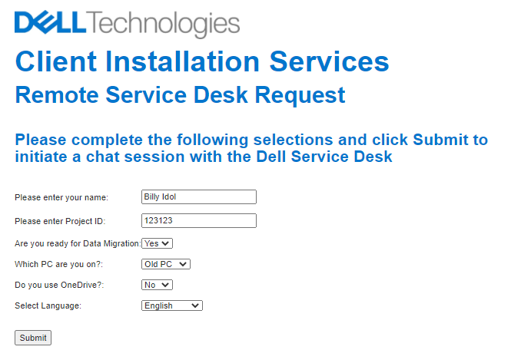

* 1. You will be placed in a queue. Once connected with a Dell Service Desk agent you will be prompted to download an applet. Accept the download and acknowledge the popups.
  2. If the customer has a firewall there will be a popup requesting permission to allow access. Click Allow access.
  3. If UAC is enabled, you will see a message to accept a UAC Prompt. Click OK.

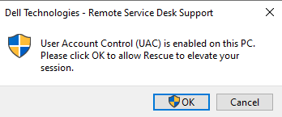

1. Once the applet is downloaded, the Service Desk will request permission to gain remote control of the customer’s computer. You will receive another popup that says: Dell Agent would like to perform one or more actions on this computer, including the following:
   * Control or view your desktop
   * View system information
   * Transfer, delete, overwrite or copy files and folders
   * Reboot
   * Run Scripts

Click OK. At this point the remote connection has started.

1. Ensure the connection steps are performed on both the old and new systems. Once connected on both systems, Service Desk will send the following verification: **Remote Connection Established.** DMT Process will start.

If the backup is complete (should be the case with OneDrive, Service Desk will confirm) you can complete the deinstallation of the legacy system. If backup is not complete, leave both the new and legacy system connected to both internet and power and explain to the customer how to disconnect the legacy system once complete. Place any unused hardware components in the computer box, or as directed by customer. Move deployment trash to an on-site disposal area. Restore the installation area to its original condition and have the customer sign the CAF.

Troubleshooting

If you have issues establishing the remote connection and are still unable to get through after the third try, please reach out to the Dell Service Desk per the contact info below:

* US, Canada: <amer.install.services@dell.com>
* Mexico, Brazil: [LATAM_SOImagenes@Dell.com](mailto:LATAM_SOImagenes@Dell.com)
* UK, France, Germany: Contact your Engagement Manager or [CIS.EMEA.EM@dell.com](mailto:CIS.EMEA.EM@dell.com)