# Windows 10 – First time start up quick reference guide.

### This guide is intended to help you with how to navigate the out of box experience you will encounter when first powering on your new Windows 10 Computer.

## Step 1.

### Select a region.

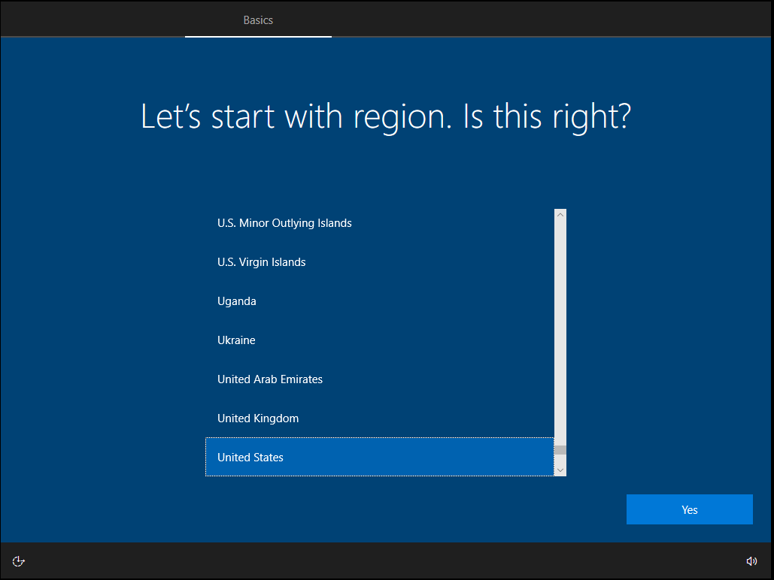

## Step 2.

### Select a keyboard layout preference.

## Step 3.

Select additional keyboard (optional). 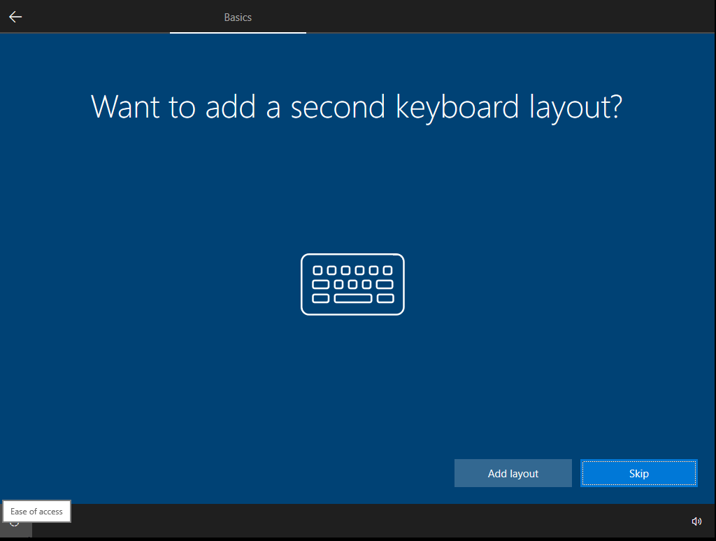

## Step 4.

### Connect to a network.

### A network connection is required for a proper setup. (NOTE: If you’re *already* connected to a network, you will not see this screen.)

## Step 5.

### Account setup.

### Select how you would like to use your computer. (Note: unless instructed otherwise by your administrator, select “Set up for personal use.”) Alternatively see “Setup for organization” for a walkthrough on those steps.

## Step 6.

### Account setup.

### On this screen you can either create a new Microsoft account, or enter an email address of an existing Microsoft account. If you prefer to not use a Microsoft Account, select “Offline account” in the lower left of the screen. If you enter an email address that is not associated with a Microsoft account, you will be asked to create one.

## Step 7.

### Create a PIN.

### A PIN is different from your Microsoft Account password. It allows for an easier and more secure way to login to your personal system. This PIN is unique to this device, and will not be used anywhere on the web, or other devices.

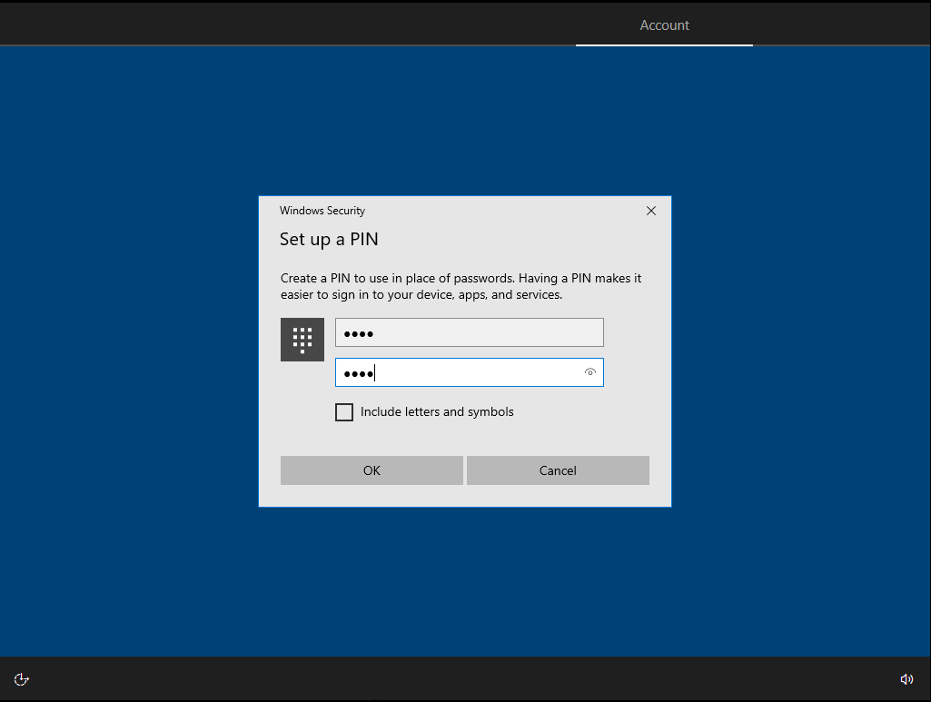

## Step 8.

### Choose privacy settings.

### Based on your personal preference you may customize your privacy settings on this screen. For purposes of this guide, we keep the default settings.

## Step 9.

### Customize your device.

### On this screen you can select all the ways you plan to use your device. This is mostly so Microsoft can provide suggestions on tools/games and services. For this guide we leave all boxes unchecked as default and select Skip.

## Step 10.

### Connect your phone.

### Adding your Android phone allows you to receive texts, photos, and notifications on your Windows 10 device.

## Step 11.

### Backup Settings.

### This screen allows you to decide how you want to backup your files. Either in OneDrive (the cloud) or on this PC. If you wish to save on this PC select “Only save files to this PC” in the lower left of the screen.

## Step 11.

### Setup Cortana.

### Cortana is a virtual assistant. It can be used for voice input, speech and handwriting patterns, searching the web. And provides other suggestions.

### Once you complete these steps, you will be ready to use your new Windows 10 system.



## Step 5A.

### Setup for organization.

### Click setup for organization, and enter in the credentials provided by the organization.

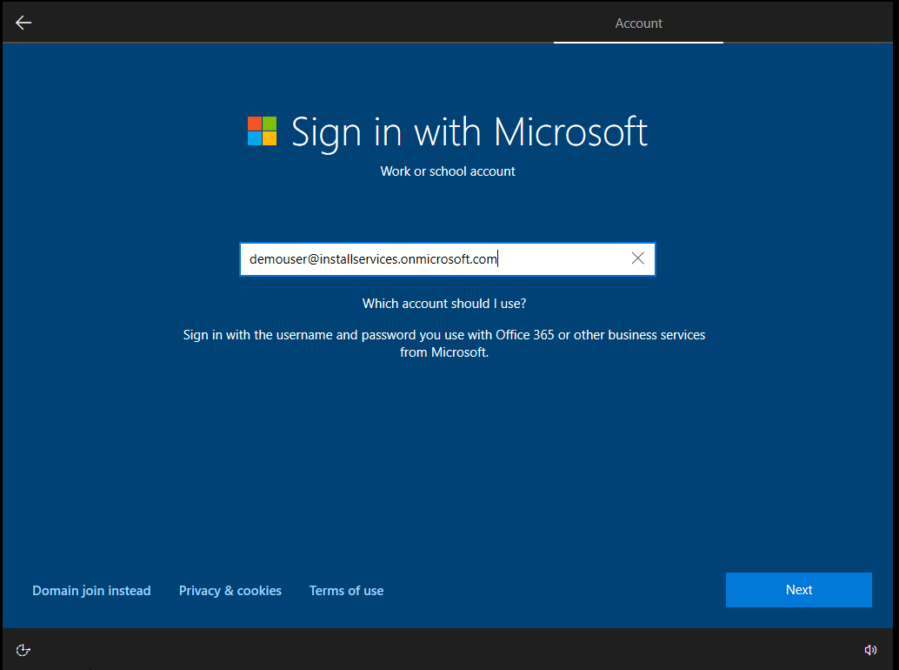

## Step 5B.

### Enter password provided by your organization. (you may be prompted to change this on first login.)

### You are done.

## Step 6A.

### Offline Account Setup.

##### To create a Microsoft Account and after choosing “Offline Account.” You will need to select “limited experience”.

### Step 6B.

### Create a user account.

### Step 6C.

### Create a password. And confirm your password.

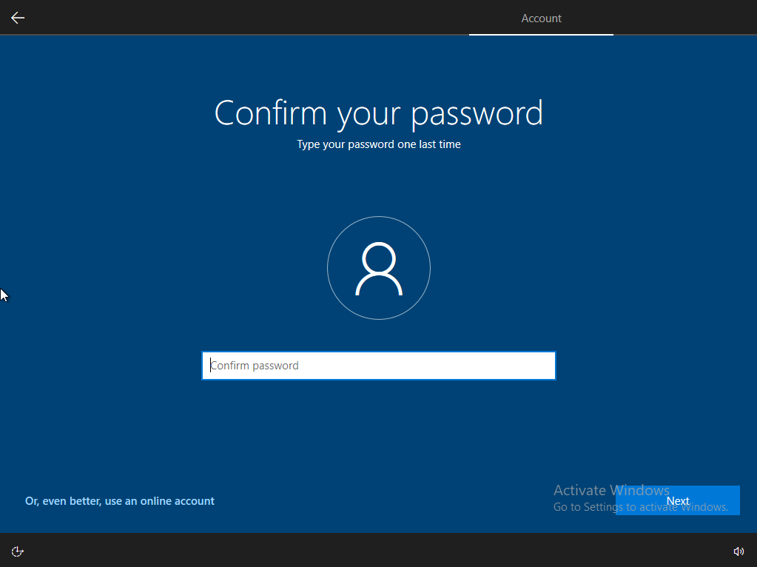

### Step 6C.

### Create security questions for this account.

### Step 6D. Choose privacy settings.

## Based on your personal preference you may customize your privacy settings on this screen. For purposes of this guide, we keep the default settings.

## Step 6E.

### Setup Cortana.

### Cortana is a virtual assistant. It can be used for voice input, speech and handwriting patterns, searching the web. And provides other suggestions.