RescueMe and Remote Data Migration Guide

March 2021

# Revisions

|  |  |
| --- | --- |
| Date | Description |
| March 31 2021 | Initial Release |

# Acknowledgments

Author: Andrew Korb

The information in this publication is provided “as is.” Dell Inc. makes no representations or warranties of any kind with respect to the information in this publication, and specifically disclaims implied warranties of merchantability or fitness for a particular purpose.

Use, copying, and distribution of any software described in this publication requires an applicable software license.

This document may contain certain words that are not consistent with Dell's current language guidelines. Dell plans to update the document over subsequent future releases to revise these words accordingly.

This document may contain language from third party content that is not under Dell's control and is not consistent with Dell's current guidelines for Dell's own content. When such third-party content is updated by the relevant third parties, this document will be revised accordingly.

Copyright © February 2021. Dell Inc. or its subsidiaries. All Rights Reserved. Dell Technologies, Dell, EMC, Dell EMC and other trademarks are trademarks of Dell Inc. or its subsidiaries. Other trademarks may be trademarks of their respective owners. [3/31/2021]

# Table of contents

Revisions 2

Acknowledgments 2

Table of contents 3

1 How to install the Technician console 4

2 Setting up Technician console 5

3 Quick Call flow 6

4 Tools for the job 7

5 Initiating new support session with Onsite tech. 8

5.1 Initiate chat with Support Rep 8

5.2 **Initiate Remote control session of customers computer** 9

5.3 Download/push the tools needed for CIS 10

6 How to Start a PC Session via PIN Code 11

7 How to Create and Edit Scripts 13

8 How to Transfer Files Between Computers using File Manager 15

9 Request customer system information 17

10 Setup Predefined Replies/URLs 18

11 Managing Data Migration that extends past working hours 20

11.1 Requesting extended unattended access 20

12 What do I do if the Rescue Me connection drops? 21

13 What is the process if the customer does not answer ping to perform data verification? 22

14 How to Search for DMT Completion in GDMS 23

15 OneDrive options if the sync did not complete by the time the tech is onsite. 25

16 Tech View and Customer View 26

# How to install the Technician console

* **Option 1.** Click this link to [download and install the desktop app](https://secure.logmeinrescue.com/TechConsole/DesktopApp/Download.aspx)
* **Option 2.** Log in to your account at the LogMeIn Rescue website (<https://secure.logmeinrescue.com/account/login>) and go to the My Account page. Click the link to download the desktop app.

**NOTE:** You will need Local administrator to install this software. You can request local admin by clicking **Start > Opening Software Center > Search for “Local Administrator rights – install”**

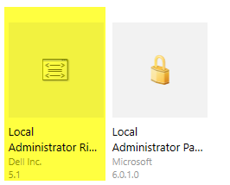

|  |  |
| --- | --- |
| Launch the file that you downloaded from either Option 1 or Option 2 above. | |
| Step 1. Click Next | Step 2. Select Language |
| Step 3. Click Next   Step 5. Accept the default installation path | Step 4. Accept the End-User License Agreement   Step 6. Click Install |

# Setting up Technician console

**To run the application:** Launch the application via the Windows Start button, a desktop shortcut, or any other preferred method. You may be prompted to log in to your Rescue account. Use the same email and password combination you use to log in at the LogMeIn Rescue website.

For the most part the technician console is completely customizable to make your job and role easier. However, there are a few columns required to help identify the service the customer is needing, as well as which machine you’re connecting to.   
  
The required columns include: **Name, Session ID, Status, Time, Channel, Project ID, Ready to Migrate, Using One Drive, Transferred by, System Identifier.**

Steps to modify the column

1. Right Click the column headers
2. Select the columns listed above to display
3. You the order of columns are up to you.

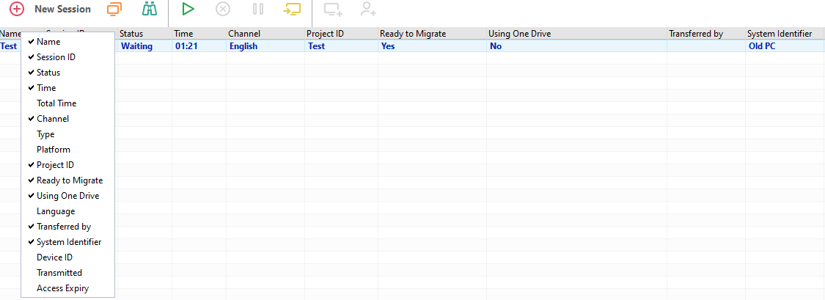

# Quick Call flow

1. Answer call in chat queue, use the predefined chat options to help streamline the process. (Initiating support session with onsite tech)
2. Request permission to gain access to the computer and push down the remote applet.(initiate Remote control session of the customers computer.)
3. Verify the technician has setup the New PC in the final location, the Source PC is setup and that they are able to connect you to that as well.
4. Push the tool URL to the customers computers and download the DMT package.(Download/push the tools needed for CIS)
5. Determine whether the customer is doing a OneDrive migration or a Network PC to PC
6. Follow the directions per the [DMT CIS Work Instructions](https://dell.box.com/v/DellRemoteCIS) per the proper scenario identified, Network PC to PC or Cloud Sync Migration (OneDrive).
7. Inform the technician that you have remote connection to both machines. Ask them to clean up their work area, notify the customer that they are done and to explain that Dell will be monitoring the remainder of their migration.
8. Request extended remote access time if you believe the migration will extend past the work shift. Requesting unattended access

* Managing Data Migration that Extends past working hours?
  + Requesting unattended access
* What do I do if the Support Session drops?
* What is the process if the customer does not respond to data verification?
* OneDrive options if the sync did not complete by the time the techs are onsite

# Tools for the job

The following link will provide all the necessary tools to assist customers with their data migration, and troubleshooting:

<https://dell.box.com/v/DellRemoteCIS>

E.g. DMT executables, DMT CIS Work instructions, PreDeploy script, and other troubleshooting tools.

# Initiating new support session with Onsite tech.

As a CIS Support technician, you will be monitoring a chat queue for onsite technicians to establish a connection between the customer’s Source and Target PC.   
  
When a new session joins the queue, you will be notified by a sound within the Rescue Me App.   
  
1. Highlight the session in the queue and click the “Start Session” button highlighted below.   
  
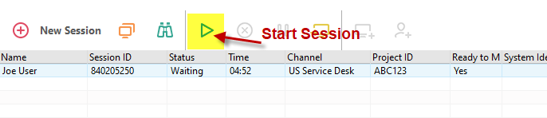

2. Prompt the customer to download the Applet. 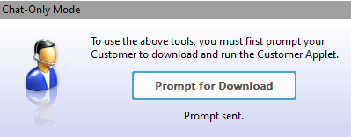

3. Click Launch remote session.

## Initiate chat with Support Rep

To begin the session, you will have to communicate with the onsite tech via chat,   
feel free to use the loaded welcome messages that you downloaded and imported. In previous steps.

1. To utilize the Predefined replies, click on the 4 lines to the lower right of the chat box.
2. Select the reply you wish to use.

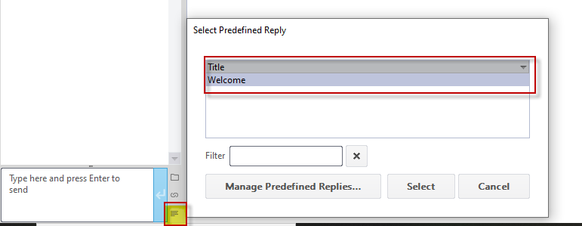

## **Initiate Remote control session of customers computer**

During Instant Chat, remote control can only be started once the customer has downloaded the Rescue Applet.

1. On the Technician Console Customer Desktop tab, click **Launch Remote Control Session**.   
     
   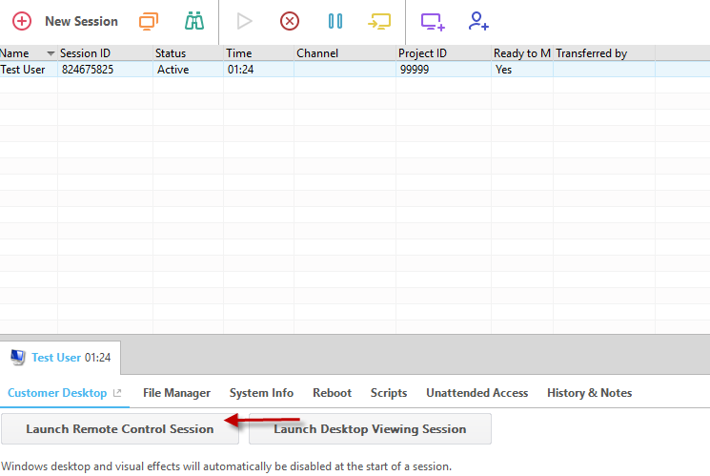

The customer is prompted to accept or decline your request to control his computer.

1. Ask the customer to accept the request.

Remote control begins.

1. Use the Remote-Control toolbar to manage the remote session.

All other Workspace tabs remain available.

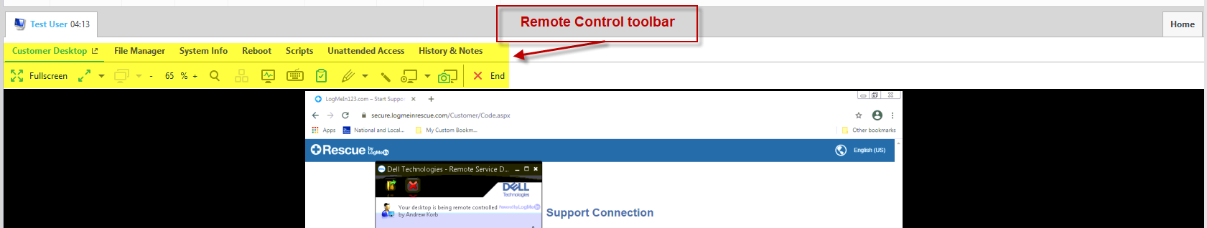

1. To end remote control, click the red **X** on the Remote Control toolbar.

Remote control ends, but the session remains active.

## Download/push the tools needed for CIS

1. Similarly, to using the predefined replies. You should also save the CIS Remote tools link so that you can push it to the end users’ systems. See “How to setup predefined URL” to setup.
2. If you do not have Predefined URL saved, you can manually navigate to http://eucservices.net/CISDMT on the customer’s computers
3. Follow the DMT CIS Work instructions for the scenario you’re running, Network PC to PC or Cloud Sync Migration (OneDrive).

# How to Start a PC Session via PIN Code

1. On the Session toolbar, click **New Session**.

The Create New Session window is displayed.   
  
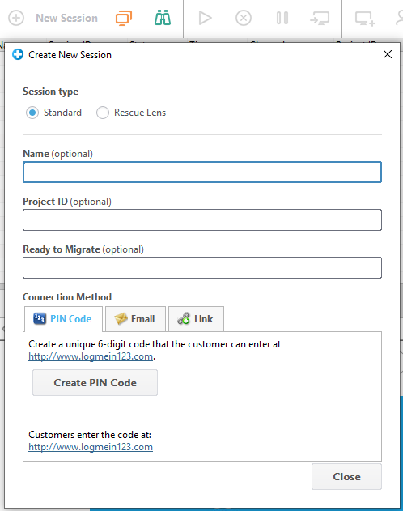

1. Type the customer's name or other identifier in the **Name** field.

You will use this name to identify the session on the Active Session tab and in the Session List.

1. Select the **PIN Code** tab.
2. Click **Create PIN Code**.

Rescue generates a 6-digit PIN code and displays it in the Generate New Session window and in the Session Log.

1. Ask the customer to go to the PIN code entry site.

Desktops and notebooks connect at [www.LogMeIn123.com](http://www.LogMeIn123.com).

**Tip:** Cannot access www.LogMeIn123.com? Try [www.123Rescue.com](http://www.123Rescue.com).

1. The customer enters the PIN and clicks **Connect to technician**.

The customer will see a dialog box asking him to download the Rescue Applet.

1. Tell the customer to download the Applet.

The download should take about 15 to 30 seconds.

**Note:** The download procedure may vary depending on the customer's operating system and browser.

1. Once the download is complete, ask the customer to click **Run** to execute the Applet.

Once the Applet is installed, the customer status will change from Connecting to Waiting.

1. Pick up the session by selecting it in the Session list and clicking **Start**.

Customer Status will change to Active.

# How to Create and Edit Scripts

1. In the Console Status area, select **Tools** > **Manage Scripts**.

The Manage Scripts page is displayed.

1. Click **Add New**.
2. Name the new script in the **Script name** field.
3. Next to the **Script file** field, click **Browse** to locate the pre-written script.

The script file must be present on your computer.

1. Use the **Resource file** field to attach any other file needed to run or support the script.

A resource file is any file that you send to a customer via the script. For example, if the script sends a ZIP file to the customer, the ZIP file is the resource file.

The resource file must be present on your computer.

1. To make the script run automatically when a session starts, select **Execute when Applet starts**.
2. Select the operating system(s) on which the script will run.
3. Click **Save**.

Scripts will be listed in the Local Scripts section on the Scripts tab and will be available for deployment during an active session.

Click **Import** or **Export** to import/export script definitions from/to an XML file.

Click the up and down arrows to the left of a numbered script to change the order in which scripts will execute.

**Remember:** Only those scripts will run automatically that have the **Execute when Applet starts** box selected.

**Tip:** Sample scripts are available in the [LogMeIn Community Script Repository](http://community.logmein.com/t5/Rescue/Rescue-Script-Repository-Thread-Share-your-scripts/td-p/22331).

**Tip:** You can find your most frequently used scripts more easily by making them favorites. Click the star icon next to the script you want to make favorite.

The script appears on your **Favorite Scripts** list.

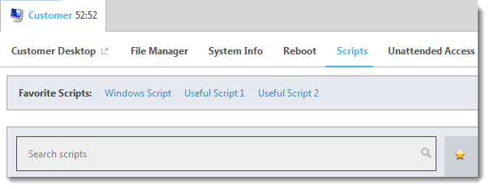

You can have maximum five scripts on your Favorite Scripts list.   
  
How to Deploy a Script  
  
Follow this procedure to deploy a script during an active session.

**Script deployment** must be enabled at the Technician Group level in the Administration Center.

1. Click the **Scripts** tab.

A list of available scripts is displayed.

1. Select the script you want to deploy.
2. Click **Deploy**.

The script is deployed.

**Remember:** Running an embedded script manually requires the **Run embedded script** permission to be set in the Administration Center.

Embedded scripts are configured by Administrators in the Administration Center.

# How to Transfer Files Between Computers using File Manager

Transferring files between computers is as easy as selecting files and dragging them to the appropriate folder. Otherwise, use the appropriate options on the File Manager toolbar.

| **Option** | **Icon (Windows client)** | **Shortcut (Windows client)** | **Description** |
| --- | --- | --- | --- |
| Copy |  | Ctrl+C | Copy the selected file or folder from the existing location to the selected new location. The copied file or folder is now in both locations. |
| Move |  | Ctrl+X | Cut a file or folder from the existing location and move it to the new location. The moved file or folder is now only in the new location. |
| Synchronize |  | Ctrl+S | Update the current folders to the client and host so that their contents are the same. Files and folders that exist only on one side are copied normally. If both folders contain one or more files that are different on the client and host, the newer version will be copied.  The folders must be open, not simply selected. |
| Replicate |  | Ctrl+R | Files and folders that do not exist in the destination folder are copied normally. Files that already exist in the destination folder will be transferred from the source folder. If a destination folder contains a file or a folder that does not exist in the source it will be deleted.  This is very useful if you update the Source folder and want to push those changes to the Destination. |

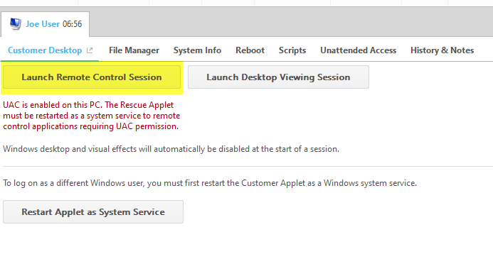

# Request customer system information

Requesting customers system information is useful to gather what is running on the system, and certain hardware specs, such as How much hard drive space is available, or what services are running.   
  
First you need to Start a session (see Initiating new support session with onsite tech. for a refresher)

Go to the System Info tab

Once the session is Active, click the Technician Console **System Info** tab. You’ll see lots of other tabs, like Processes, Services, Applications, and more. Click **Request Information** on any tab.

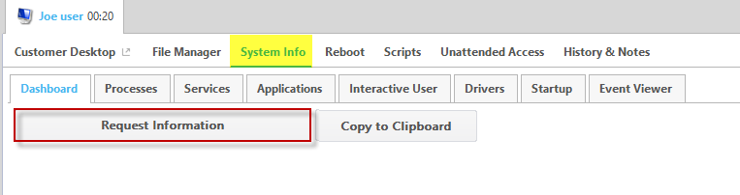

The customer may be prompted to accept or decline your request to pull information. If so, ask the customer to accept the request. The info appears on your screen.

# Setup Predefined Replies/URLs

Predefined Replies/URLs can be pushed to customers computers, and auto launch for them. This can be used to send automatic pre-determined messages, or push URLs needed to perform the migration tasks or troubleshooting.

1. Click tools from the Rescue chat window.

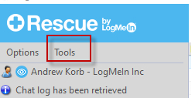

1. Click “Managed Predefined Replies

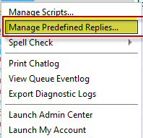

1. Click “Predefined URLs tab and selected “Add New” Or Click Predefined Replies Tab and click New

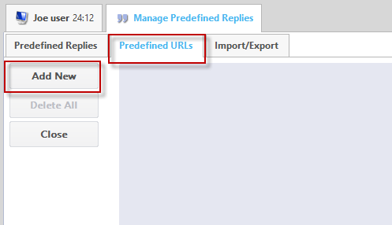

1. Name the URL CIS Remote Service, and paste the URL <https://dell.box.com/v/DellRemoteCIS> in the Content tab.

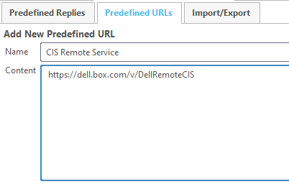

# Managing Data Migration that extends past working hours

1. Transfer session to an available technician.
2. Request that the customer allows the Service Desk Agent (EMEA EM) to check back in remotely on the computer.

## Requesting extended unattended access

1. From the technician console select the “Unattended access tab”
2. Check the option for “At setup. Customer enters credentials at setup of unattended access.”
3. Select how many days you require unattended access. Request no more than 2-3 business days if the day you are requesting falls on a weekend.

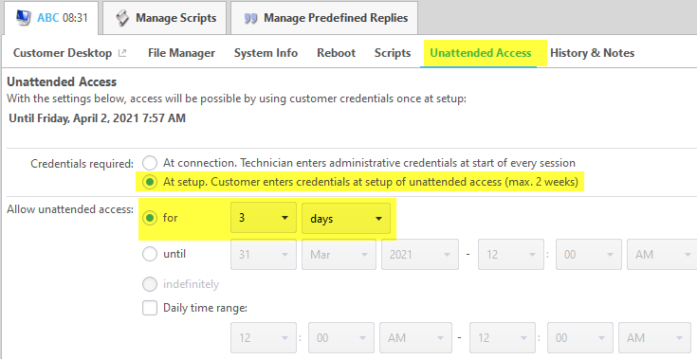

# What do I do if the Rescue Me connection drops?

1. You should have a chat message that instructs the customer to rejoin the chat session in the event of disconnect.
2. Rescue Me should rejoin automatically in case of a disconnect, but if prolonged disconnect occurs, the customer will need to re-establish connection.
   1. In EMEA, the EM can reach out on the phone.
3. Another option is to request 24-hour permission to auto rejoin to their system. Will need to request 3-day permission if remote data migration falls on a Friday and we need to follow up on Monday.

# What is the process if the customer does not answer ping to perform data verification?

US/LATAM (GRD):

* 1. Service Desk will ping the customer to perform the data verification. If the customer doesn’t respond, Service Desk will keep the ticket to keep the ticket open through the end of their shift to await a response. If the customer still doesn’t respond, Service Desk to take a screen shot of the DMT completion in GDMS (see instructions below) and attach the screen shot to BOLT, then close out the BOLT.
  2. EM is copied when the BOLT is closed out, then the EM will send an email to the customer confirming the data migration is complete and will provide direction to contact the EM for any questions/issues.

EMEA:

1. EMEA EM will ping the customer to perform the data verification. If the customer doesn’t respond, EM will call the customer. If the customer doesn’t answer the call, EM will close out the chat and send an email: “Your data migration is now complete. If you have any questions or concerns, please reach out to me via chat or phone and I’ll be happy to assist you.”
2. Data Migration completion details can be found in GDMS, see instructions below.

**If you obtain customer acceptance via chat, get a screen capture of the customer’s approval, and attach it to the BOLT(US/LATAM) or in GDMS(EMEA)**

# How to Search for DMT Completion in GDMS

1. Log into [GDMS](https://gdm.dell.com/#/login) (ensure you are on Dell VPN to access). Click on Project Management icon in the top ribbon. Then enter the Deployment ID (Project ID) from the BOLT and uncheck “Primary contact projects,” then Filter. The Project will show at the bottom of the page. Click the Project Name hyperlink.

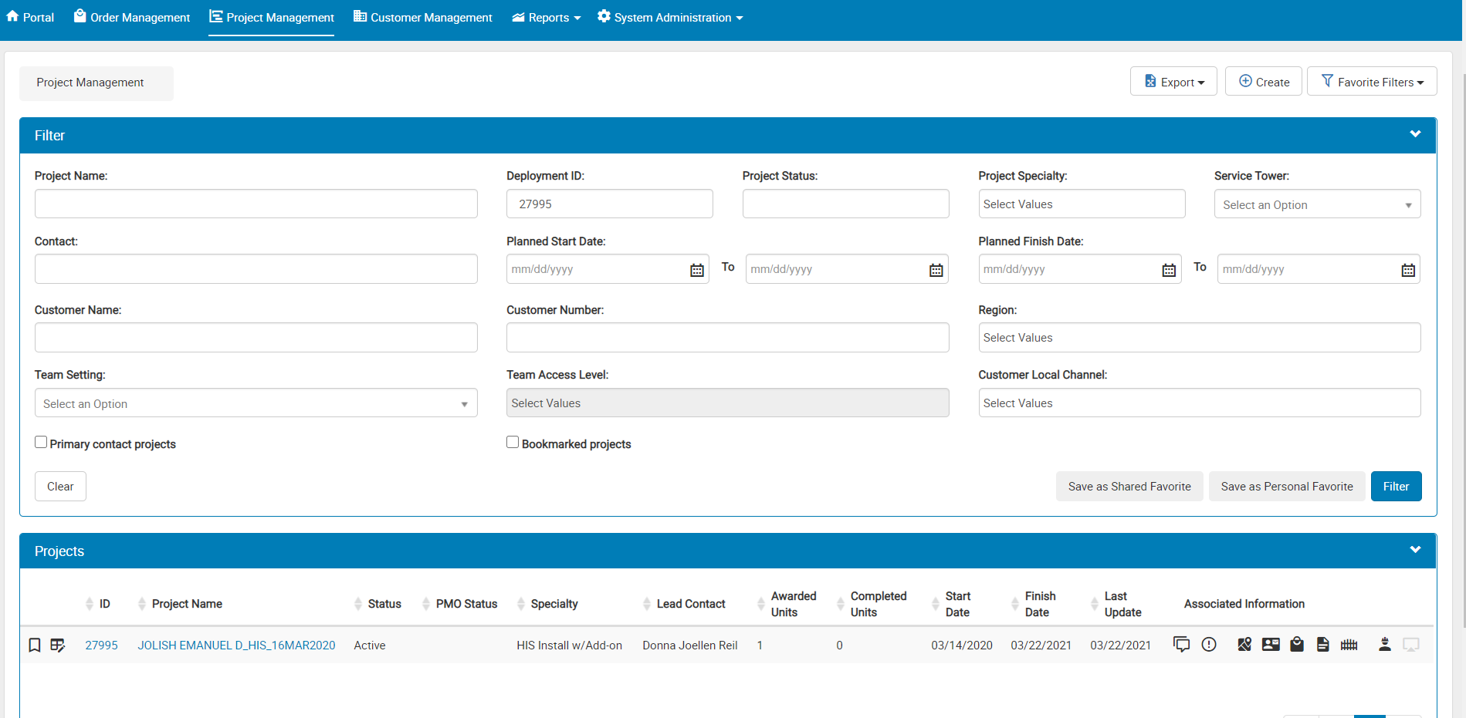

1. 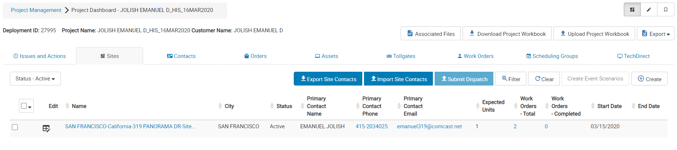Click on the Sites tab, then click the Site Name hyperlink.
2. Once in the Sites table, click on the Work Orders tab, then click the edit icon on the Work Order.

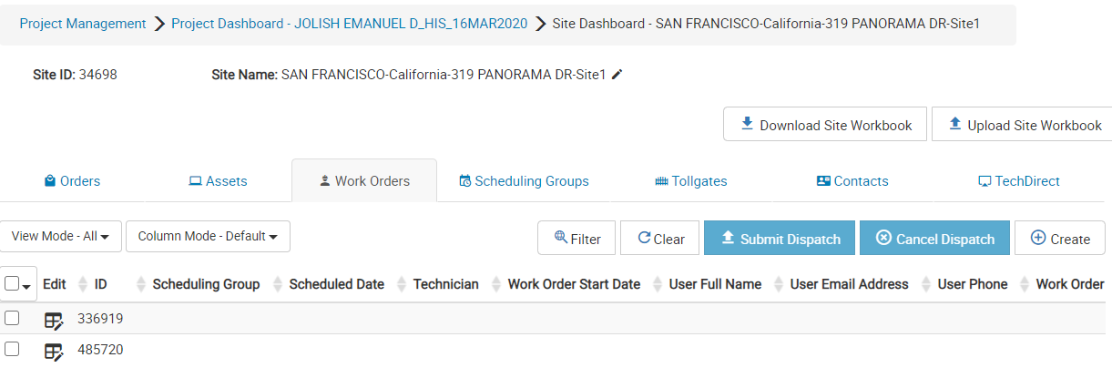

1. Click on the Work Details tab, then DMT New Asset.

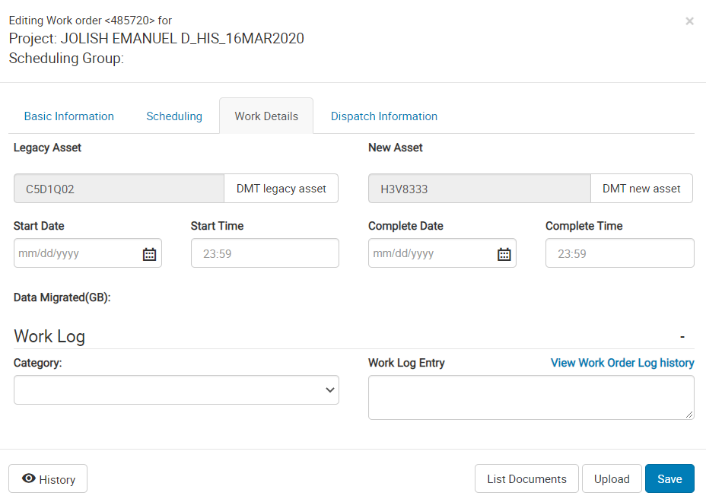

1. From here you can see the Start/End time of the Backup (under Old Asset) and the Start/End time of the Restore (under New Asset). You can include this screen shot

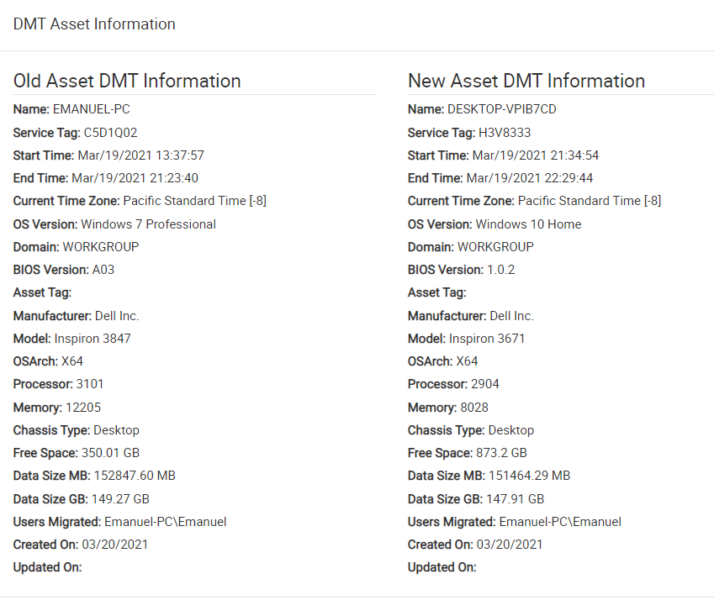

# OneDrive options if the sync did not complete by the time the tech is onsite.

1. If sync is complete, convey to the tech to disconnect from old and move on to setup the new computer.
2. If sync is still in progress, inform the customer to continue to leave the old computer on and connected to the internet. Run DMT with OneDrive on the new computer so it can pull the sync data from OneDrive as soon as the legacy completes.
3. If the backup was not started or the customer never contacted the service desk, we will perform the data migration using Network PC to PC via the normal DMT process.

# Tech View and Customer View

Technician View:

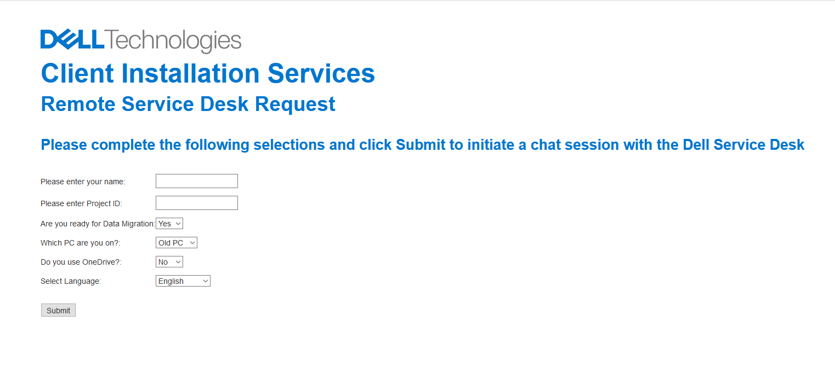

Customer View:

These are the steps the customer will see when downloading the support applet.  
  
1. When you initiate the prompt to download the Applet, they will be prompted in chat.

“Technician Name would like to start an operation which requires an applet to be downloaded”

2. Save file prompt once the applet link is clicked

3. UAC prompt for running the file.

4. Remote control prompt once they run the applet and you initiate control. They have 30 seconds to accept this window.

